**6MMCS002**

**Digital Marketing, Social Media and Web Analytics**

**Vassiliki Bouki**

**Tutorial 1:** The aim of this tutorial is to provide an introduction to tutorials, explain the teaching schedule and the topics we’ll cover in this module as well as to explore more the topic of ‘web marketing’ with exercises, research and further reading.

**Part A: about the module and the tutorials**

**1)** Purpose of the tutorials and activities during tutorials’ time (Type of activities: presentation by the tutor, discussion) **[Time: approx. 5-8 minutes]**

Purpose

* + Clarify topics / terms / issues from the lecture
  + Repeat and go in depth on topics presented in the lecture
  + Give the chance to students to work on their own

Activities

* + Explore topics; further reading; do your own research
  + Exercises that improve understanding; complete tasks
  + Explore tools
  + Learn new tools that you’ll use for the coursework (google sites)
  + Students’ presentation on the coursework for feedback purposes
  + Work on the coursework

For several exercises you are expected to work independently eg do your own research - reading

**2)** Explain the teaching schedule (Type of activities: presentation by the tutor, discussion) **[Time: approx. 8-10 minutes]**

We’ll go through the file ‘Teaching SCHEDULE’ that is on Blackboard. It is important to make sure that students are clear about the topics we’ll cover, the assessment criteria and deadlines, as well as the learning objectives. Slides 4-10 from lecture notes can be used with emphasis on slides 7 and 8.

**Part B: Web marketing**

**1) Exercise 1:** Clarify terms (Type of activities: presentation, discussion, reading. Students work with the rest of the class and on their own) [**Time: approx.** **20 minutes**: 5 minutes presentation, 10 minutes reading, 5 minutes discussion]

* Make sure you have a clear understanding about the following terms:
* Suspect - **All the visitors are suspects**
* Prospect – **The suspects who have gain interest in the web site and browsing through it.**
* Lead - **The prospects who have given their details to get more information.**
* Retention. Give your own definitions for: ‘first time buyer’, ‘repeated customer’, ‘evangelist’
* First time buyer – **A lead who is purchasing an item for the first time from the site**
* Repeated customer – **A lead who returns to your business and repeatedly buys products or services.**
* Evangelist – **A customer that will buy products from the business and also share the experience with others who don’t know about the business.**
* Make sure you understand that there are different definitions for the above terms and sometimes they interchange places.
* Have a look in the following pages:
* <http://www.marketo.com/ebooks/how-to-define-a-lead/>

**2) Exercise 2:** Acquisition Methods ((Type of activities: reading, search, discussion. Students work on their own and with the rest of the class) [Time: **approx. 20 minutes**: 15 minutes reading and search; 5 minutes discussion]

Go to lecture notes, slide 25. In slide 25, the acquisition methods are presented. Are you familiar with them? Read the PP file ‘acquisition_methods’ that you can find on BB and make sure you understand the acquisition methods. Do your own search online and identify sites that use those acquisition methods.

**Different acquisition methods**

* Search Engine Optimization (SEO) - T**he process of improving your site to increase its visibility when people search for products or services related to your business in Google, Bing, and other search engines**.
* Pay-per-click (PPC) advertisement (e.g., Google Adverts) - **Where you pay search engines and websites to advertise your website or products.**
* Banner - **Banner advertising refers to the use of a rectangular graphic display that stretches across the top, bottom, or sides of a website or online media property**.
* Affiliates - **Any Affiliate of Participant, and any agency, agent or other third-party representative that receives Brand Income or enters into Brand Income Contracts on behalf of Participant.**
* Email marketing – **Marketing through email lists formed over the time through the web site or a email list provided by some other third party.**
* Social media marketing - **the use of social media and social networks to market a company's products and services**

**3) Exercise 3:** Ash’s funnel and Miller’s buying circle. (Type of activities: introduction by the tutor, reading, discussion. Students work on their own) **[Time: approx. 30 minutes]**

The following two figures describe the ‘Ash’s funnel’ and ‘Miller’s buying circle’ models.

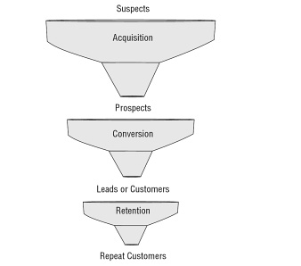 Ash’s funnel

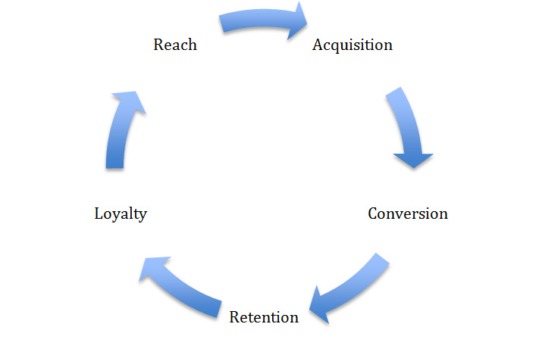Miller’s buying process

* Compare and discuss the above figures / models:
* What are the differences?

|  |  |
| --- | --- |
| **Ash’s funnel** | **Miller’s buying process** |
| Only have steps up to retention | Has the loyalty member step to retain the customer |
| Since there’s no loyalty process its less lightly the customer would recommend the service to another one | The loyalty customer would recommend the service to another person then a new circle would be formed. |
| The process is best suited for the customers who would less likely get the service for short period time. | Best suited for customers who would more often use the service in the future. |
| The customer is not aware of the service you provide in the beginning | The customer is aware about the service you provide |
|  |  |

* What are the similarities?
* Both have the similar steps in the process.
* Which model represents better reality?
  + Reflect on how you behave as an online prospect, lead, customer

**As an online prospect Miller’s buying process is better than ash ‘s funnel, since the prospect is already aware of the service you provide and no need of new introductory.**

* + Do these models work for any type of conversion action or company?

**4) Exercise 4:** Landing pages (Type of activities: reading, search. Students work on their own) **[Time: approx. 15 minutes]**

Read the Blackboard file ‘Landing Pages Types and Examples’ – explore the web addresses given in this file.

**5) Exercise 5:** Retention methods (Type of activities: reading, search. Students work on their own) **[Time: approx. 15 minutes]**

Go to lecture notes, slide 32. In slide 32, the retention methods are presented. Do your own online search for each methods. Make sure you understand all terms.

* There are many retention methods that can be used during the marketing process.
* **Send a welcome email when browsing through the site for the first time.**
* **Have a way to contact the customer get their details and send messages about discount products and any details regarding the services.**
* Making the customer stay on the web site for long time or having them visit daily base should keep them update about the products and services.
* Giving the customer a rewards system to keep them active and letting them redeem their rewards is good way.
* Posting daily content and let them like and share your content(Instagram , Facebook)

6) Identify the differences between web marketing and traditional marketing

|  |  |
| --- | --- |
| **Traditional marketing** | **Web marketing** |
| **Often expensive** | Cost effective |
| **No direct interaction with the consumer** | Can have direct interaction with consumer with messaging platform. |
| Can cover up for larger audience | Less audience |
|  |  |

**Attention:** If you do not have enough time to complete all the above exercise during the tutorial, you are expected to work on your own and do them at your own time.